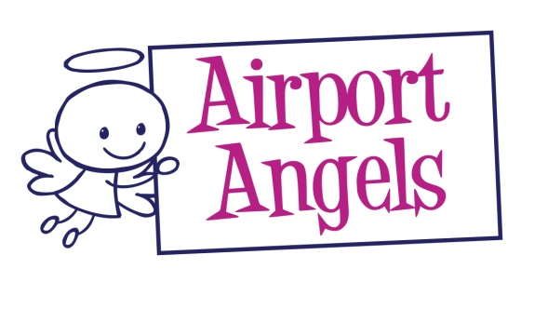
GSAT

General Security Awareness Training

Why is a GSAT training course required?
EU and Department for Transport legislation states that all airport staff who require an airside staff pass (that is who require access to the Security Restricted Area) must first attend a General Security Awareness Training (GSAT) course.

The GSAT Training Course
This GSAT training course has been specifically designed for the internet. It features professional film sequences taken at a major UK airport, easy-to-understand pictograms, on-screen text to emphasise key points and a glossary of abbreviations and technical terms. With their vast international experience of technical training, CD Media Training has produced an up-to-date, interesting and stimulating programme that will inform and educate every employee. It is not a series of slides transferred to the internet, but a programme designed with every airport worker in mind.
At the end of the course, there is a multiple choice test which has to be taken in order to receive a certificate. This certificate is required as part of the application for an airport pass.

The GSAT training course covers
- The threat to aviation
- Objectives and organisation of aviation security
- Security Restricted Area and access control
- Prohibited articles
- The trainees role in aviation security

